24CSI024-DATA STRUCTURES AND ALGORITHMS
NAME:HADHISH R
ROLL NO:25BAD029
DATE:31.07.2026
Experiment 1: Implementation of Insertion Sort Using Array
Aim
To implement the Insertion Sort algorithm using an array and sort the elements in ascending order.
Pseudo code:
START
Read n
Read the array elements
FOR i = 1 to n-1
key = arr[i]
j = i - 1

WHILE j >= 0 AND arr[j] > key
arr[j+1] = arr[j]
j = j - 1
END WHILE

arr[j+1] = key
END FOR

Print the sorted array
STOP
Program
#include <stdio.h>

int main()
{
int arr[100], n, i, j, key;

printf("Enter number of elements: ");
scanf("%d", &n);

printf("Enter array elements:\n");
for(i = 0; i < n; i++)
scanf("%d", &arr[i]);

for(i = 1; i < n; i++)
{
key = arr[i];
j = i - 1;

while(j >= 0 && arr[j] > key)
{
arr[j + 1] = arr[j];
j--;
}

arr[j + 1] = key;
}

printf("Sorted Array:\n");
for(i = 0; i < n; i++)
printf("%d ", arr[i]);

return 0;
}
Output
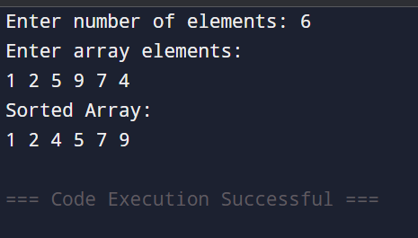

Result
Thus, the Insertion Sort algorithm was implemented successfully and the array was sorted in ascending order.

Experiment 2: Find the Kth Largest Element Without Sorting
Aim
To find the kth largest element in an array without sorting the entire array.
Pseudocode
START
Read n
Read the array elements
Read k

Call QuickSelect(arr, 0, n-1, k-1)

FUNCTION QuickSelect(left, right, k)
Partition the array using a pivot

IF pivot index == k
Return pivot element
ELSE IF pivot index > k
Search left part
ELSE
Search right part
END IF
END FUNCTION

Display kth largest element
STOP

Program
#include <stdio.h>

void swap(int *a, int *b)
{
int temp = *a;
*a = *b;
*b = temp;
}

int partition(int arr[], int left, int right)
{
int pivot = arr[right];
int i = left;

for(int j = left; j < right; j++)
{
if(arr[j] > pivot)
{
swap(&arr[i], &arr[j]);
i++;
}
}

swap(&arr[i], &arr[right]);
return i;
}

int quickSelect(int arr[], int left, int right, int k)
{
if(left <= right)
{
int p = partition(arr, left, right);

if(p == k)
return arr[p];
else if(p > k)
return quickSelect(arr, left, p - 1, k);
else
return quickSelect(arr, p + 1, right, k);
}
return -1;
}
int main()
{
int n, k;

printf("Enter number of elements: ");
scanf("%d", &n);

int arr[n];

printf("Enter elements:\n");
for(int i = 0; i < n; i++)
scanf("%d", &arr[i]);

printf("Enter k: ");
scanf("%d", &k);

printf("%dth Largest Element = %d", k, quickSelect(arr, 0, n - 1, k - 1));

return 0;
}
Output
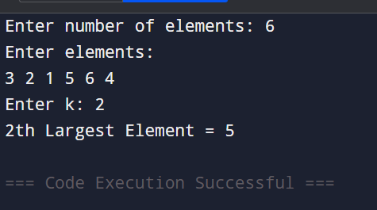

Result
Thus, the kth largest element was found successfully without sorting the entire array.

Experiment 3: Sort Characters by Frequency
Aim
To sort the characters of a string in decreasing order based on their frequency.
Pseudocode
START
Read the string

Count the frequency of each character

WHILE there are characters remaining
Find the character with the highest frequency
Print the character frequency number of times
Set its frequency to zero
END WHILE

STOP
Program
#include <stdio.h>
#include <string.h>
int main()
{
char str[1000];
int freq[256] = {0};

printf("Enter a string: ");
scanf("%s", str);

int len = strlen(str);

for(int i = 0; i < len; i++)
freq[(unsigned char)str[i]]++;

while(1)
{
int max = 0, index = -1;

for(int i = 0; i < 256; i++)
{
if(freq[i] > max)
{
max = freq[i];
index = i;
}
}

if(max == 0)
break;

for(int i = 0; i < max; i++)
printf("%c", index);

freq[index] = 0;
}

return 0;
}
Output
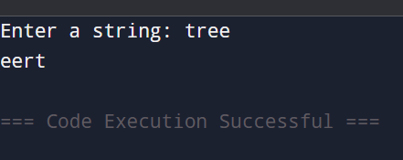

Result
Thus, the characters of the string were successfully sorted in decreasing order based on their frequency.

